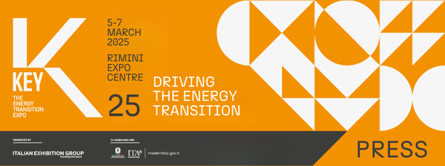

press release
(English translation)

IEG: KEY AND FEDERCOSTRUZIONI SIGN MEMORANDUM OF UNDERSTANDING

- A three-year collaboration until 2027
- Signed by Corrado Peraboni, CEO of Italian Exhibition Group, and Paola Marone, President of Federcostruzioni

Rimini, 7th March 2025 – Promoting the energy supply chain in the built environment and the solutions available to energy-intensive sectors to reduce emissions and the environmental impact. This is the objective shared by Italian Exhibition Group and Federcostruzioni, which signed a memorandum of understanding today.

The agreement, with a duration of three years, until 2027, was signed by Corrado Peraboni, CEO Italian of Exhibition Group and Paola Marone, President of Federcostruzioni.

The new collaboration aims to consolidate KEY - The Energy Transition Expo’s growth strategy and to support the other initiatives linked to the event through the involvement and participation of associations registered with Federcostruzioni, Confindustria’s federation that represents the Italian construction industry and groups together the building, infrastructure, materials, engineering and facility market’s most significant production categories.

Federcostruzioni was already participating at the current edition of KEY with a special space in the exhibition area dedicated to energy efficiency, where talks, meetings and presentations were held, attended by several of the Federation’s trade associations.

The partnership foresees an enhancement of Federcostruzioni's activities at the 2026 and 2027 editions of the event. In addition to involving the 16 member associations, thus favouring the cluster dedicated to energy efficiency, and organising events and conferences in collaboration with KEY’s Technical Scientific Committee, the Federation will produce new content related to the construction supply chain’s activities in support of decarbonisation policies and the risks and opportunities these may generate for Italian companies.

At KEY25, Federcostruzioni organised the following events: on Wednesday 5th March, “Local flexibility markets and price signals: digitalisation in support of business flexibility”, “The storage system market in Italy: trends and opportunities”, and “The market for renewable energy sources in Italy: trends and opportunities”, while “The energy that moves everything: Energy and sustainability in the construction supply chain” was held this morning.

ABOUT KEY 2025
Event: International trade show; Organization: Italian Exhibition Group S.p.A.; Frequency: annual; Edition: 3rd; Dates: 5-7 March 2025; mail keyenergy@iegexpo.it; Website: http://www.key-expo.com; Facebook: https://www.facebook.com/keyexpo/; Instagram: https://www.instagram.com/key_expo/; LinkedIn: https://www.linkedin.com/company/keyenergy/

PRESS CONTACT KEY - ITALIAN EXHIBITION GROUP
head of media & corporate communication: Elisabetta Vitali; press office manager: Marco Forcellini, Pier Francesco Bellini; international press office coordinator: Silvia Giorgi; press office coordinator: Luca Paganin; press office specialists: Nicoletta Evangelisti, Mirko Malgieri; media@iegexpo.it

MEDIA AGENCY: Smartitaly Communications
Sara Scatena, s.scatena@smartitaly.it, mob. +39 338 7836985; Arianna Geli, a.geli@smartitaly.it, mob. +39 347 0917903

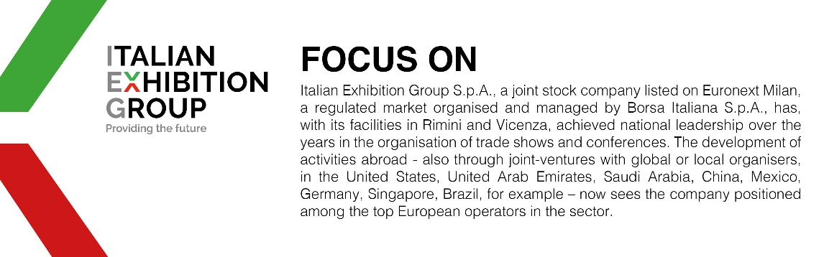

This press release contains forecast elements and estimates that reflect the management’s current opinions (“forward-looking statements”), particularly regarding future management performance, realization of investments, cash flow trends and the evolution of the financial structure. For their very nature, forward-looking statements have a component of risk and uncertainty, as they depend on the occurrence of future events. The effective results may differ (even significantly) from those announced, due to numerous factors, including, only by way of example: food service market and tourist flow trends in Italy, gold and jewellery market trends, green economy market trends; the evolution of raw material prices; general macroeconomic conditions; geopolitical factors and evolutions in the legislative framework. Moreover, the information contained in this release does not claim to be complete, and has not been verified by independent third parties. Forecasts, estimates and objectives contained herein are based on the information available to the Company as at the date of this release.

